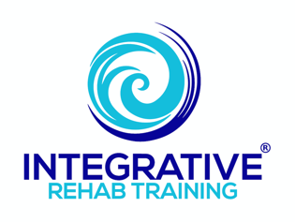
PRI Interdisciplinary Studies Summit 2024
Michael J. Mullin, ATC, PTA, PRC

- Supplemental Manual Therapy Techniques to Assist in Restoring System Neutrality

Presentation abstract:
There are a number of considerations professionals should be cognizant of when performing any manual technique for the best outcomes for both practitioner and patient. The Postural Restoration Institute has a large compendium of manual techniques which help provide an entry into restoring balance to dominant patterned polyarticular chains. Practitioners should have a clear image of what they are trying to accomplish with patients with any hands-on approach. This presentation seeks to educate others on important concepts as it relates to performing manual therapy in general, as well as provide supplemental techniques to further help with establishing a neutral entry-point for PRI-activities to help build upon.

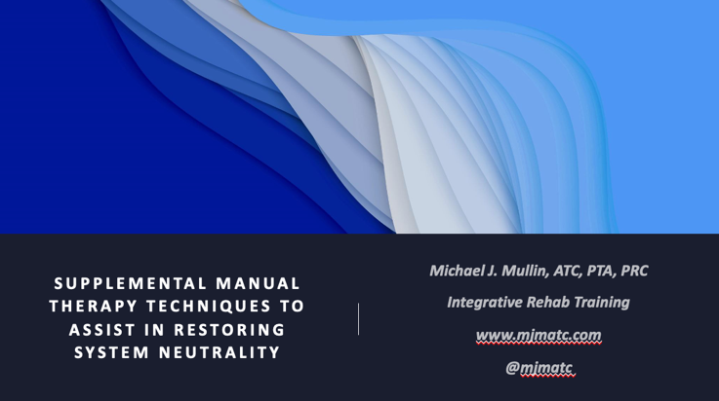
This presentation on “manual therapy” could really be called “intervention strategies and considerations”. There are numerous people who may read this material who do not do any hands-on work. So this will hopefully provide a learning opportunity from several different angles vs. it just being a manual therapy lecture.
Everything that follows represents a component of my current thought process of what I do, what I’ve found helpful in my interventions, my interpretation of things I have read, what I have learned through the Institute and all its avenues of education, as well as numerous other sources. Please recognize that this is my current thought process, which is different than when I originally submitted my abstract, which is different from when I submitted my material, and would likely be a little different two weeks from now :)

I am now, and have basically always been, on a constant search for clarity—a better understanding of this amazingly complex organism that we all possess. That others have entrusted themselves to us to help them with. I have spent—I don’t even want to think about how much time and resources on improving my art.
I have tried for so many years to act as kind of an interpreter for others. To deep dive into understanding something better, write about it mostly for myself, then try and share my interpretations so that others can benefit. Everyone wins that way—myself, my clients and other professionals.
Three goals I have always had as a professional:
  - To get better
  - To help my clients get better
  - To help other professionals get better
Which means I am constantly looking for more answers and better answers, which means I am constantly asking more and—hopefully—better questions.
Which brings us to today’s topic on manual interventions. While the title states “manual therapy techniques….”, it is really about better understanding what it is happening internally with any intervention we introduce with our clients and ourselves.
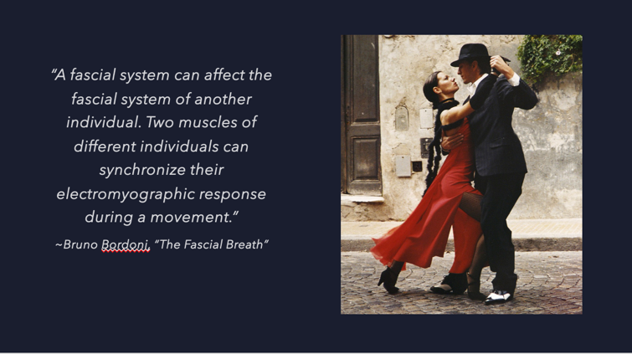
- "A fascial system….”
  - Synchronize, entrain, harmonious….it is like these two beautiful dancers doing the tango. Connected physically, performing their own movements, yet with both being acutely aware of what the other is doing. Awareness and connection….
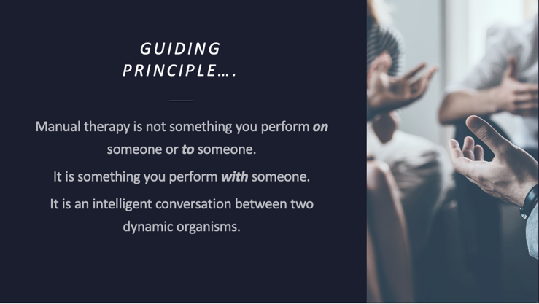
- Guiding principle
  - We are all guides. Our ability to communicate effectively with our clients, through a multitude of different ways, is what allows us—and them—to be successful.
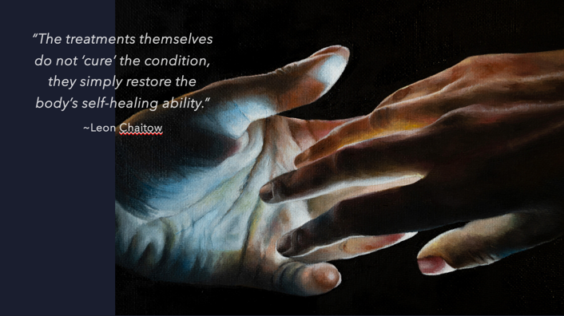
- ‘Cure’ the condition
  - We are not a dominant supervisor, trying to micromanage and telling people what to do. We are a conductor of the symphony of the human body, helping people coordinate all of their instruments to produce harmonious rhythms.
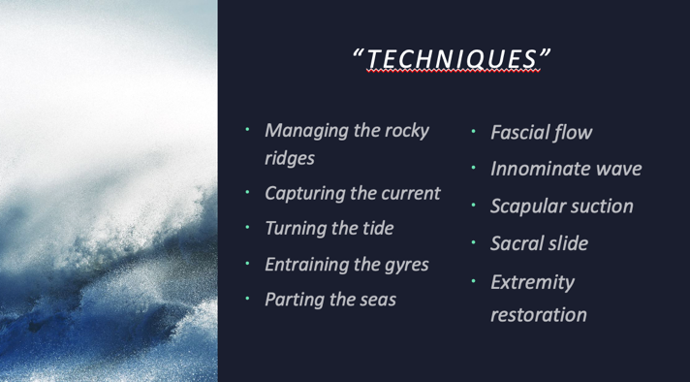
- "Techniques”
  - The goal of this presentation is not to teach a new treatment algorithm, or new specific techniques, but if I were to name some of the things I will demonstrate, I would call them something like this.
  - As will be discussed and demonstrated: fluid flow, water dynamics, bony prominences, torqued and bent structures, lack of relative movement and other similar concepts is what is important to grasp more than any specific ‘techniques’.
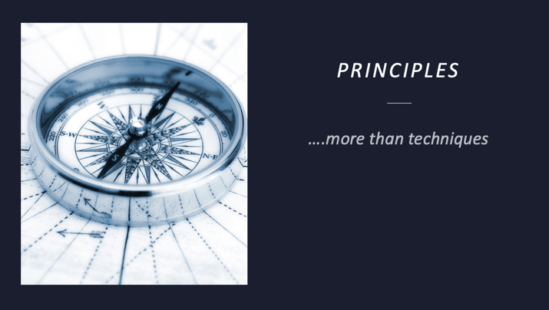
- Principles more than techniques
  - Guide decisions
  - Intervention algorithms are estimations
    - They provide frameworks with which to work with, but they can be self-limiting and linear.
  - We want individual sessions and the entire course of care to be smooth. PTs have known this a long time, which is why they use what are called “flow sheets”.
  - But what if something disrupts that flow? Someone experiencing pain with an activity on the flow sheet disrupts the flow just like a post in a river disrupts the flow of the stream. Yet water can smoothly change its dynamics to allow it to adjust to this. We should strive to be able to exhibit those same qualities.
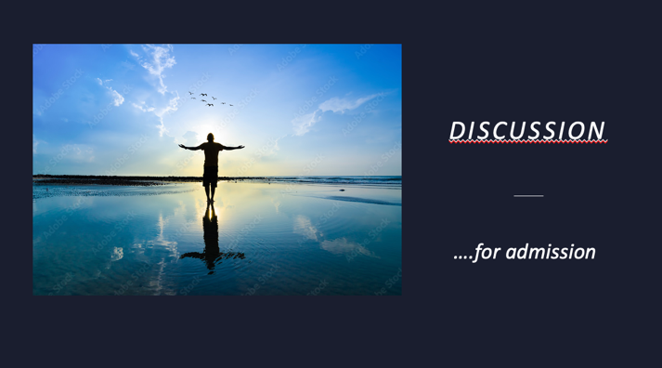
- Discussion for admission
  - Environment we provide for our sessions
    - Foundational set-up
      - Color or walls, tables, equipment, pictures on walls, etc.
    - General
      - Cleanliness, orderly, organized,
    - In-session considerations
      - Music in background, lighting, background noise, no Smartphones or other wearable devise
      - Your energy….
  - Manual intervention discussion
    - For their understanding
    - To provide context for them to feel safe
    - To reinforce their understanding of what the treatments are trying to accomplish

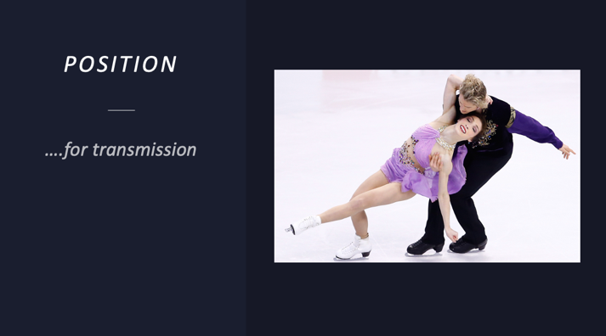
- Position for transmission
  - Meryl Davis & Charlie White
    - This is a picture from their gold medal winning performance at the 2014 Sochi Winter Olympics. Do yourself a favor and watch it. It is absolutely breathtaking for many reasons.
      - First of all, it is absolutely stunning in its performance for all the things that can be seen on the surface from a skill and judging perspective—composition, presentation and skating skills.
      - What is also so clearly evident is their connection—their personal as well as coupled energy, their clear love for what they do and are doing in that moment, the flow and grace with which they demonstrate every aspect of their performance.
      - Having been fortunate to have spent some time with them when I was doing work with Stars On Ice, this is how they are as humans—beautiful, humble and positive. And I remember talking with Charlie once and him sharing how he senses contact, weight and momentum. And Meryl mentioning the coordination of visualization happening during the actual performance. Flow state….
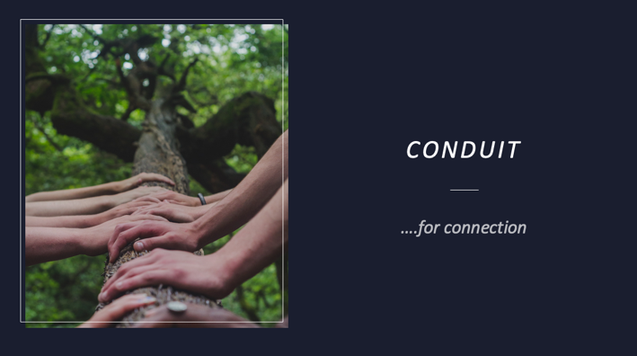
- Conduit for connection
  - A channel for conveying water or other fluid
  - A tube or trough for protecting electrical wiring
  - Passing something from one place or person to another
  - Balanced, pressurized, electrically and chemically charged fluid-filled system acting upon another like structure. Entrainment….
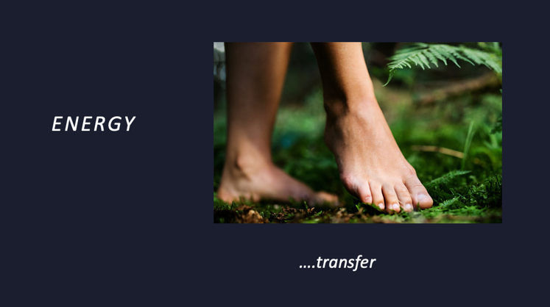
- Energy transfer
  - Energy is the capacity for doing work and exists as potential, which is stored energy and the energy of position; or kinetic which is motion of waves, electrons, molecules, substances, objects, etc.
  - Energy is often changed from one form to another and then used to do work.
    - Potential
      - Chemical, mechanical, nuclear and gravitational (i.e. stored energy)
    - Kinetic
      - Radiant, thermal, motion, sound and electrical
  - Our bodies function through charged chemical signals (which is energy stored in bonds of atoms and molecules), partially influenced by mechanical elements (i.e. biotensegrity of the energy stored in objects by tension) along with gravitational influences which emit mostly infrared radiant electromagnetic energy that travel in transverse waves which will develop thermal energy from the movement of the atoms and molecules in our substance while its motion producing the motility of this radiant and thermal energy onto the recipient.
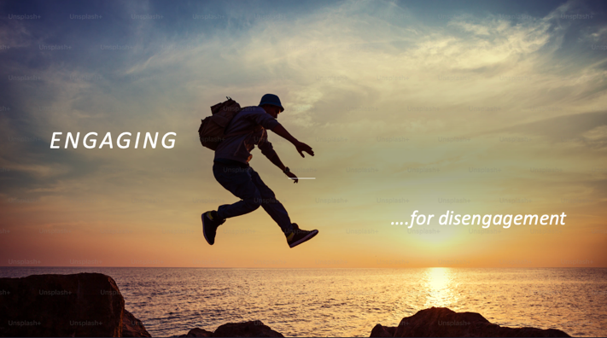
- Engaging for disengagement
  - Our interventions, or engagement, is about trying to create an appreciable change. Appreciable by the professional in their objective and/or visual assessments, but even more importantly, change which can be appreciated by the client. Our engagement might be in the form of a manual technique, a non-manual technique, movement changes, education for clarity or reinforcement of safety and the like. It might also be introducing a salient sensory input.
  - Disengagement is letting go of previously held patterns, positions and processes which are comfortable—too comfortable. However we engage with them, it should feel safe, have context, should not be overwhelming, and allow them to feel successful on their own.
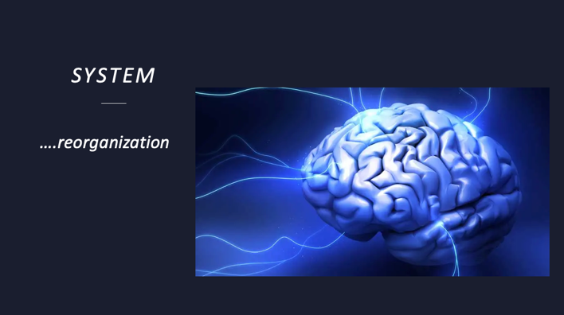
- System reorganization
  - We are trying to help bring an organism from one state to another. Physically, physiologically, neurologically, sensorially.
  - When interventions are employed—especially any hands-on work—the change that can occur at the deepest level can be profound. Respecting the degree of ‘reorganization’ taking place is way more than just changes in objective measures.
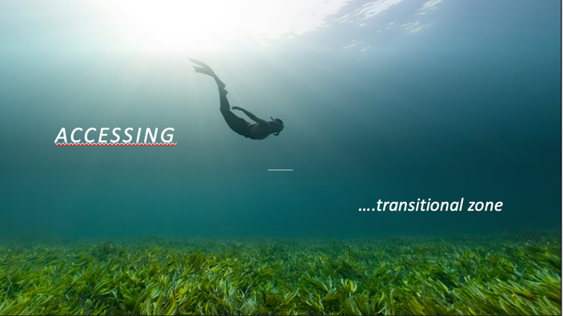
- Accessing transition zone
  - Water has positive buoyancy, negative buoyancy and a neutral buoyancy. This neutral buoyancy is at about 30 feet below the surface in deep water, the place where gravity and buoyancy play a reciprocal role in their influence on the organism.
  - It is also where the balance of positive and negative buoyancy is maintained based on weight, lung inflation, etc.etc.
  - The book “Deep” by Richard Nestor does a “deep dive” :) into organisms under water, echolocation, etc. It’s a great read.
  - We are constantly trying to get our clients to appreciate this transitional zone—to shift, sway or swing their way through it while at the same time recognizing and being able to appreciate it. They have to “let go” in order to sense this.
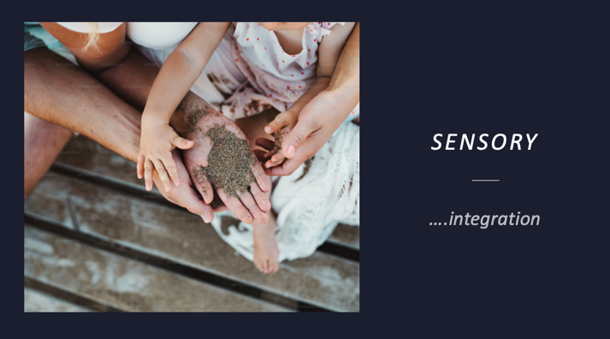
- Sensory integration
  - First, safety
    - Your environment, demeanor, background and foreground influences
  - Second, comfort
    - With surroundings, with you, with themselves
  - Third, understanding
    - Of what you’re trying to accomplish, what is going to happen and what they may sense during the process
  - Next, pressure
    - External as well as internal
  - Safety, again
    - They need to feel comfortable knowing they are in charge, they can ‘tap out’ at any time
  - Changes
    - Appreciating interoceptive changes in what they are used to feeling vs what you are trying to have them feel
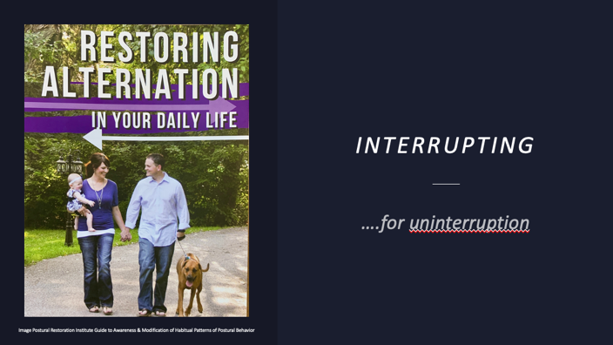
- Interrupting for uninterruption
  - Any intervention we provide is an interruption—a disruption to their sometimes strongly held patterns and beliefs.
  - “Uninterrupted” can refer to many different things. As it relates to forward locomotor movement it requires disengagement, then reorganization, to access the transition zone between different cycles. The “interruption” we introduce with manual or non-manual techniques.
  - “Uninterrupted” balance over one leg is considered to me more of a ‘static’ movement, whereas, ‘interrupted’ balance is more of a dynamic movement.
    - If I am standing on one side and not perturbed in any way, then it would be considered “uninterrupted”—traditional balance exercises. However, “human locomotion requires uninterrupted alternating lower extremity exchange of weight support”.
  - Neutrality allows for interruption
  - We are looking for interrupted perturbation. Interference that might have once been a threat to balance and safety to no longer be so.
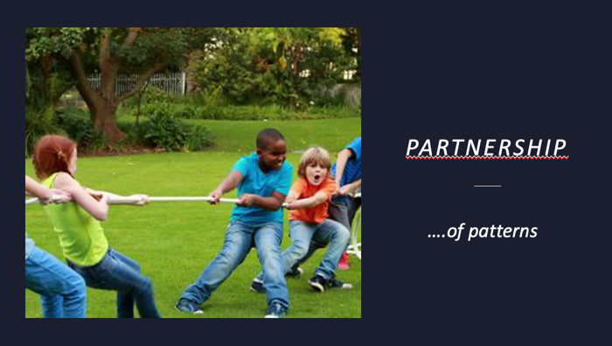
- Partnership of patterns
  - When I first started my journey into better understanding these polyarticular chains and pattern dominance, I had in my head this battle of good and evil—how one chain was holding the body hostage and wasn’t allowing it function appropriately: L AIC vs R AIC or R BC vs L BC.
    - My earlier, more primitive understanding and its correlation to our earlier, more primitive patterns and reflexes.
  - We are interrupting long held patterns—physical, physiological, mental, emotional, behavioral, spiritual….very powerful patterns.
  - Depattern, so we can have them repattern. Creating synchrony from dysynchronism
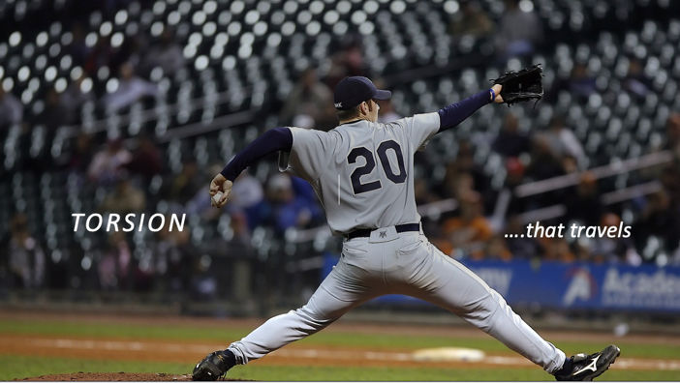
- Torsion that travels
  - Torsion travels along structures as those forces that are producing a movement also rely on mechanisms to manage those forces.
    - The longer the lever arm, and the larger the force production, the more torsion being dispersed along those lines of force.
  - “Torque is automated autonomic compensation for what someone can’t do.” (RH)
  - Trying to reduce septal tension.
  - Areas of the body are stuck in a compensatory turn. We want to unwind this so they can re-turn with a new strategy.
  - Iliacus and SCM examples of how muscles that do not run along a bony structure can end up in a twisted—or untwisted—resting position.
  - Vastus lateralis example as a muscle that runs along a bone (in picture) and how it can change its IR contractile capability.
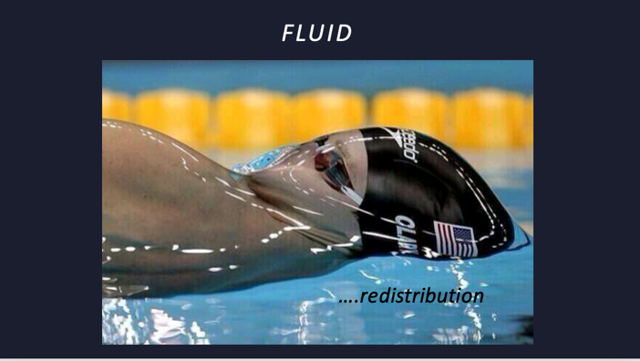
- Fluid redistribution
  - Fluid within fluid
  - Biotensegrity, hydrobiodynamics, spirolaterality
  - Surface tension concept, but more the sliding aspect of water
    - Can one molecular layer affect the surface enough(?)
    - Drop of water on the desk. Pressure, drag and lines of force.
    - Cohesive qualities of water
  - Fourth phase or EZ phase (exclusion zone)
    - Colloid crystal—molecules come together because of opposite charges; positive charge draws negative EZ shells.
    - Bowl of jello example with gait
  - Cranial, pelvic, diaphragmatic thoracic bowls “filling”
  - “Sensitive Chaos”, Theodore Schwenk
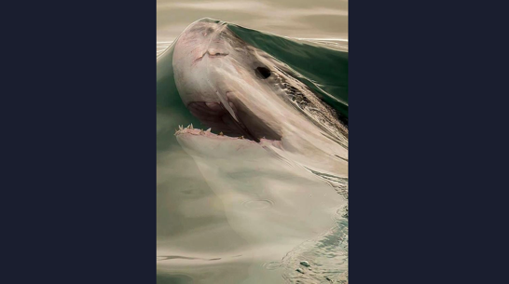
- Water’s extremely viscous nature, ability to be “bent” before breaking, much like our own internal structures.
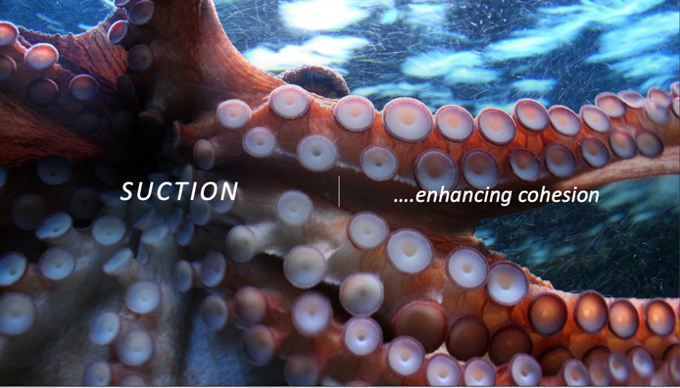
- Suction enhancing cohesion
  - Using negative pressure to move gas, liquid or solids—or a potential fourth phase—and also as is in the case with the human body, all of them at the same time.
  - Tongue on roof of mouth example, also as example of a ZOA
  - This tongue on palate demonstration also relates to the fact that concavity in general—but definitely within the body—tries to be filled.
    - Fluid and pressure dynamics will fill acetabulums, fossas, scapular concavity, etc. with something else if primary balance of primary structures are in a compromised position.
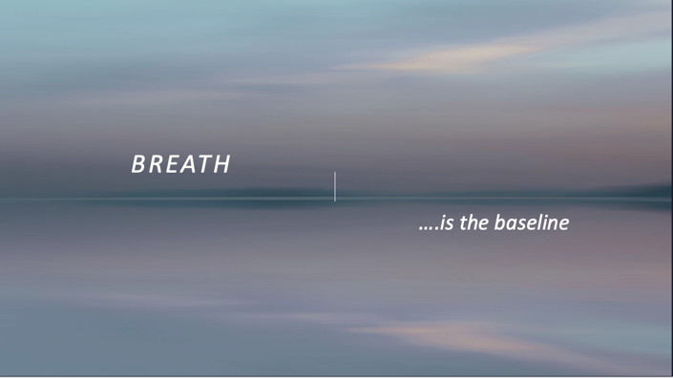
- Breath is the baseline
  - During each session, airflow is observed and then manipulated. It is the most powerful modality we have to work with, that they can then work with.
  - When we are verbally engaging, I allow the conversation to organically develop. I will observe and listen as they talk and they will be breathing in a fuller capacity because of this. The vibrations themselves are also helping with system restoration. Anytime we stop talking, I cue them to “keep your air moving”, “in on a count of 4 or so and out on a count of 5”, “slower, fuller breaths—I don’t even want to hear them”.
  - Your breath matters! Entraining your breath with theirs helps them sense it better within themselves. Your body position and physical connection coupled with deliberate breaths better aids in outcomes.
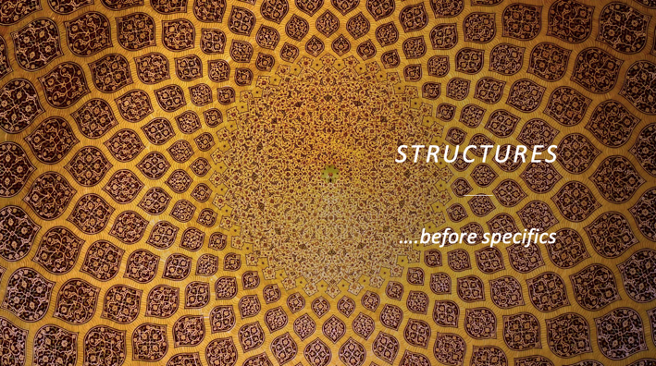
- Structures before specifics
  - Palpation for areas which don’t move—what stands out.
  - Restore the thorax and diaphragm movement first, inferior to superior. His includes scapulae and intercostal regions. Rolling them through the movement afterwards and/or having them roll through it and manipulate the breath.
  - Pelvis next trying to create movement of sacrum and innominates being able to move relatively independent of each other. Again, rolling them through the movement.
  - Limbs last
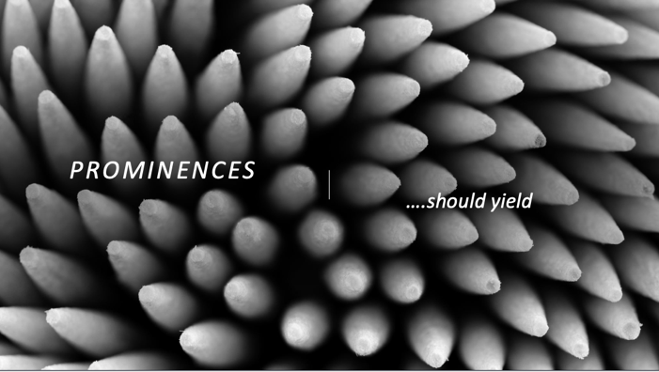
- Prominences should yield
  - When palpating structures, at times they feel too hard—they don’t yield. They are being held hostage within the biotensegrous nature of contractile and connective tissue. Limbs will feel light. I can feel a cranium and say to myself “it feels too hard and too light”.

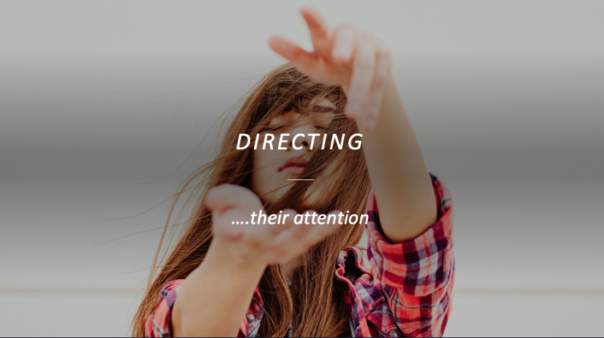
- Directing their attention
  - Having them develop a new sense of contact, movement, pressure, expansion, etc.
  - Having them breathe into an area, having them sense the movement when moving their pelvis to open an outlet, or position a scapula into a different resting place.
  - How is their head and body positioned?
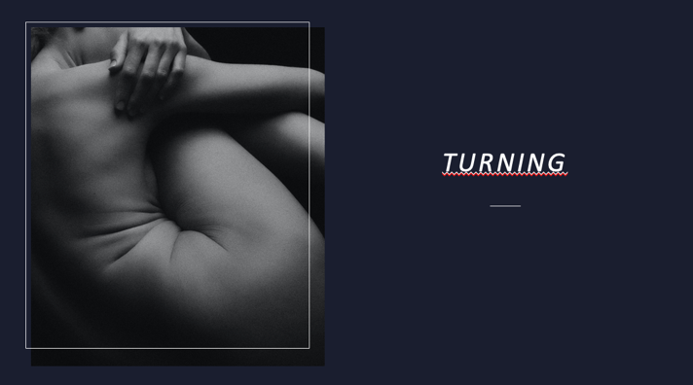
- Turning
  - As a conduit, your system is helping turn their system into different directions.
  - Turning the ground to turn and orient the system into the desired direction.
  - Tissue “folding” over and around each other.
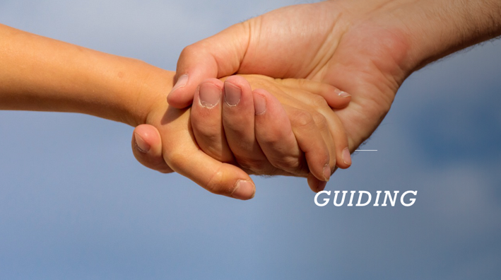
- Guiding
  - Much like one’s PRI journey, our “interventions” should really be viewed as guiding someone through a session. We are guiding their brains as well as their bodies with each element we introduce.
  - Less is more, more times than not.
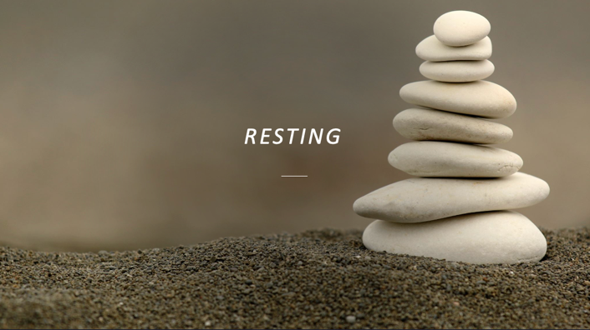
- Resting
  - Helping to create relative movements. Approximated structures have to have resting states that allow for free movement relative to each other.
    - Independence, yet interdependence.
- Thoughtful
  - Sensing directional influence and quality of tissue
  - Outmaneuvering and outsmarting
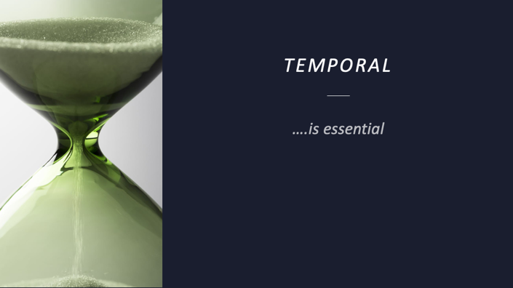
- Temporal
  - Time is of the essence. Fluids and structures need time and space to be able to fluctuate.
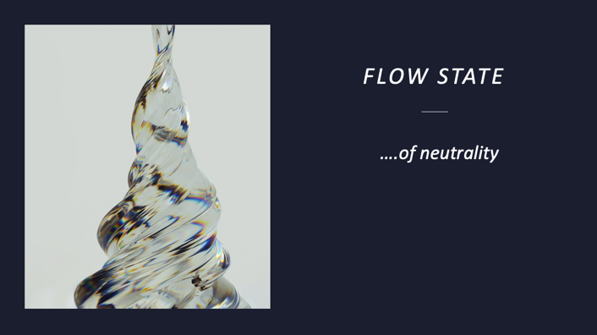
- Flow state of neutrality
  - People move to match their particular flow. If we can help someone change their flow state, then they might not need to continue. Moving to some place that supports their familiar patterned flow.
  - We have to create confusion to their system to repattern a better way to flow. It allows for interruption.
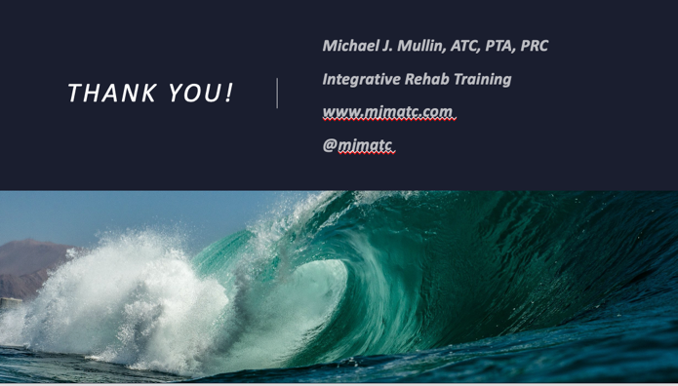
- Expansion and compression, outward and inward, spirals and vortices, coiling and uncoiling, suction and ejection….

